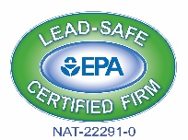
1937 South Park Ave. • Buffalo, NY 14220 • Phone: 716.823.3630 • Fax: 716.823.2967

www.nhssouthbuffalo.org • email: info@nhssouthbuffalo.org
Weatherization Assistance Program
95 Dorothy St. • Buffalo, NY 14206 • Phone: 716.837-0071 • Fax: 716.837.0244
Email: info@nhssouthbuffalo.org


Neighborhood Housing Services of South Buffalo, Inc.

March 3, 2024

Dear Representative,

The Neighborhood Housing Services (NHS) of South Buffalo, Inc. as part of their Weatherization Assistance Program is soliciting an invitation to bid for the attached specifications.
ANNUAL BID: an Hourly Rate to install Bathroom and Kitchen exhaust fans, for contract year ending May 31, 2025

Please be aware that the City of Buffalo requires that all contractors working within the municipal boundaries must be licensed by the City of Buffalo. No building permit is needed for the installation of insulation; however, “Lead Renovator” work practice certification is required for State bidding requirements. Should you have any questions concerning any permit requirements for the City of Buffalo, you can call the Permit Division at 851-4932.

NOTE: This bid is for the Weatherization program. These bid prices will stay in effect until the end of the weatherization contract March 31, 2024.

Also enclosed are our forms (#24, #28, & our terms & conditions). #24 & 28 our terms / conditions are required to be completed and returned with every bid. (#28 only needs to be submitted once per year.) Please mail or deliver sealed bids by 3:45 pm on Friday, May 17, 2024 to:

NHS of South Buffalo – W.A.P.
95 Dorothy St.
Buffalo, New York 14206

A bid opening will be performed at 4:00 pm Friday May 17, 2024at the said office located at 95 Dorothy Street, Buffalo, NY 14206

Upon approval of the bid process by the weatherization agency and the NYS DHCR authorized representative, additional required forms or documentation (i.e, Contractor Sub-agreement, Additional Insured lose payee evidence, etc.) will be required for completion of the award.

Any questions regarding the bid process and/or forms please call 837-0071 Monday through Friday from 8:00 am to 4:00 pm or email to info@nhssouthbuffalo.org .

Sincerely,

Shyrl L. Duderwick
Executive Director

Enclosures – NYS HCR Form #24, #28

General Specifications for all

Weatherization Contractor Tasks

Specifications Applicable to ALL Tasks
- All work is to comply with state and local building codes and applicable local building permits.
- This bid is for Weatherization jobs.
- Bids will be awarded to winning contractors on a per measure basis
- Contractor must submit proof of being a licensed Electrical contractor in the City of Buffalo
- Contractor must submit proof of at least (1) one EPA “Lead Renovator” Certified employee on staff
- Contractor is to make an effort for minimal disturbance to occupants.
- Contractor shall clean up all debris and disturbances at no additional cost to the agency or
Occupants.

The contractor shall supply all materials, labor, and equipment necessary to complete the work and make it whole. Work must commence as per #33 Subcontractor Agreement which will be issued for every job. All change orders must have WAP authorization prior to installation.

All services are to be provided in a polite and workmanlike manner.
- Any additional work deemed necessary by the contractor must be approved by the agency through
The use of a signed change order.
- The agency is to be notified immediately of any circumstances that exist where work cannot be
Performed due to issues such as potential safety problems or potential for damage to the home.

The agency reserves the right to reject any and all bids
All work will be inspected by this agency. Payment will be withheld until deficiencies have been corrected.

General Specifications

Quotations must be typewritten or written in ink, and corrections must be initialed. Penciled bids will not be accepted.
Late bids will only be accepted when the Authorized Representatives approve the request for an extension prior to the due date. Otherwise, late bids will not be considered.
Omissions and Discrepancies - If a Bidder is in doubt as to the correct meaning of any part of the specifications or discover any omissions or discrepancies therein; the bidder should notify the appropriate authorized representative. Additional information, when required, will be issued in the form of an addendum which will be sent to all Bidders. Addendums will become part of the initial Bid Request.
Submittals will be required to be reviewed by HCR representative and may result in removal of awarded bidder.
Warranty
The supplier warrants to Purchaser that the product will be new and not refurbished.
The supplier warrants to Purchaser that the product will be free from defects and will meet the product specifications stated.

Execution of Contract/Rejection of Bids
NHS of South Buffalo Weatherization reserves the right to:
- Reject any/or all bids
- Adapt all or any part of the Bid in selecting optimal product specifications

Non-Discrimination/Equal Opportunity
Discrimination against any individual, for reason of race, creed, national origin, sex, handicap or age is specifically prohibited.

Instructions: Carefully read the terms and conditions shown above before preparing your proposals. Please sign on lines below indicating that you have read each page of this Bid Package thoroughly and agree to all specifications, terms and conditions. Bids will not be accepted if incomplete.

Vendor Name:
Contact Person Regarding Bid:
(please print clearly)
E-Mail Address:
Phone/Fax Number:
Customer Service(order taker)  (please print clearly) | Name:  Phone:
Signature of Authorized Rep:
Printed Name and Title of Signor:

Specifications for Hourly Rate Install of Bathroom and Kitchen
Exhaust Fans and Repairs Related to Weatherization work

- Include in bid an hourly rate for installing a Kitchen and or Bathroom exhaust fans to be supplied by the NHS of South Buffalo.
- Hourly Rate to include repairs related to weatherization work
- Any openings created by contractor will be repaired to restore to its previous state in a workman like manner.
- Install all wiring to code.
- Separate bid prices into materials and labor.
- A copy of any permits filed for this project must be submitted to NHS prior to any payments being discharged.

Hourly rate for extras (no overtime) $ ________/item

SOLICITATION OF ANY WORK OUTSIDE OF WEATHERIZATION SPECIFICATIONS IS PROHIBITED. AND WILL RESULT IN TERMINATION OF THIS CONTRACT AND PARTICIPATION OF ANY OTHER BIDS

City of Buffalo Permit and any other applicable Permits/Certifications as may be required by the City of Buffalo Licensing Division

ALL INVOICES MUST INCLUDE:
- Name & Address of work order
- Number of workers & total hours worked onsite
- Material used, Notes & pictures
- Cost of permit (where applicable)
- ALL INVOICES ARE TO BE SENT TO:
billing@nhssouthbuffalo.org

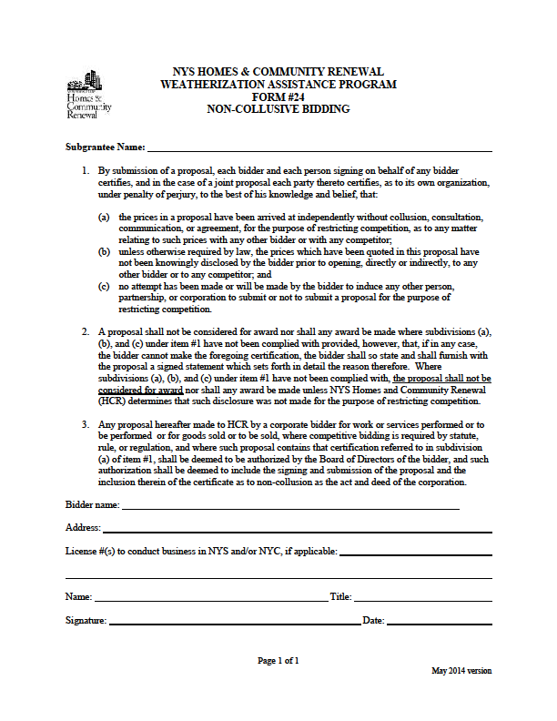

NYS HOMES AND COMMUNITY RENEWAL
WEATHERIZATION ASSISTANCE PROGRAM
HCR # 28

CONTRACTOR QUALIFICATION
The following information must be completed in order to be considered a qualified bidder.

I
Bidder Information

Legal Company Name

D/B/A

Address City State Zip Code Telephone

II
Company Structure

Corporation Partnership Individual Other
If “Other,” explain:

State of Incorporation or Registration Number Number of Years in Business

III
Principals

List the name, address, telephone number and position of each principal of the company. (Attach additional pages if necessary.) "Principal" means
each officer and director of the bidder and each shareholder, partner and co-venturer who either controls or owns, directly or indirectly, a ten percent or greater interest in the bidder or who will actively participate in the performance by the bidder of the proposed contract.

Name | Address | Phone # | Position
 |  | ( )
 |  | ( )
 |  | ( )
 |  | ( )
Which licenses does your company hold?
Plumbing # Issued by: Date:

Electrical # Issued by: Date:

Other # Issued by: Date:

If none, please explain:

IV
Bank Reference

Bank

Address City State Zip Code Telephone

Account Name Account #: Contact Person:
V
Woman/Minority-Owned Business

Is this a woman or minority-owned business? Yes No
If “Yes,” is it qualified as such with the State of New York? Yes No Certification #:

VI
Disqualification
Has this business, its individuals, partners, officers and/or shareholders . . .
(a) been disbarred or otherwise disqualified from participation in city, state or federally funded work projects? Yes No
If “Yes,” please give details:

VII
Affiliation

List all other businesses in which the majority owners, partners, officers and shareholders have held an affiliation or interest in the past five years.
(Attach additional pages if necessary.)
Name of Business | Address | Work/Service Performed | Contact Person | Phone #
 |  |  |  | ( )
 |  |  |  | ( )
 |  |  |  | ( )

VIII
WAP History

List all Weatherization Assistance Program (WAP) subgrantees for which you completed major heating system work during the past three years: (Attach additional pages if necessary.)
Subgrantee Name | Subgrantee Name

IX
Insurance

Insurance Company

Address City State Zip Code

Type of Coverage: $ Amount: Contact Person: Telephone: Are there any claims pending against your auto/general contractor liability coverage? Yes No

If “Yes,” amount of claim(s) $ $ $ $

Bonding Company

Address City State Zip Code

Contact Person: Telephone:

X
Project History
Complete the following information for each of the last five heating replacement projects of 25+ units completed by your organization:
Owner/Project Name
Address
Contact Person | Phone # | Cost of Project
Did you subcontract any portion of the contract work? Yes No

If so, approximately how much of the work did you subcontract?

Name of Subcontractor Description of Subcontracted Work

Owner/Project Name
Address
Contact Person | Phone # | Cost of Project
Did you subcontract any portion of the contract work? Yes No

If so, approximately how much of the work did you subcontract?

Name of Subcontractor Description of Subcontracted Work

Owner/Project Name
Address
Contact Person | Phone # | Cost of Project
Did you subcontract any portion of the contract work? Yes No

If so, approximately how much of the work did you subcontract?

Name of Subcontractor Description of Subcontracted Work

Owner/Project Name
Address
Contact Person | Phone # | Cost of Project
Did you subcontract any portion of the contract work? Yes No

If so, approximately how much of the work did you subcontract?

Name of Subcontractor Description of Subcontracted Work

Owner/Project Name
Address
Contact Person | Phone # | Cost of Project
Did you subcontract any portion of the contract work? Yes No

If so, approximately how much of the work did you subcontract?

Name of Subcontractor Description of Subcontracted Work

XI
Affirmation

By submission of this application, the applicant and person signing on behalf of any applicant subscribes and affirms, under penalties of law that the statements made in this application for inclusion to the Qualified Bidders List have been examined and to the best of his/her knowledge and belief are true and correct. The applicant affirms that no person named in this application is subject to disqualification under the terms and guidelines of New York City and New York State unless herein stated. The applicant understands that by signing this application it consents to any other inquiry to verify or confirm the information given herein. The applicant understands that this application for inclusion on the Qualified Bidders List does not guarantee that inclusion will be granted but will be used in the determination of eligibility for inclusion.

(Signature)

(Print Name)

(Title)
TO BE COMPLETED BY NOTARY
(in accordance with State notary requirements)

State of _____________________________
County of ___________________________

This instrument was acknowledged before me this _____day of _____________ (month), _________ (year), by___________________________________________ (name of officer or agent, title or officer or agent) of _________________________________ (name of entity).

_____ Personally Known

_____ Produced Identification

Type of ID and Number on ID ____________________________

(Seal)
________________________
Signature of Notary

____________________________
Name of Notary
(Typed, Stamped or Printed)

Notary Public, State of _______________

